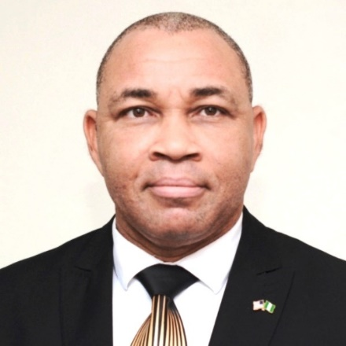

Mark Ighile, PhD is a Professor of African Literature, Oral Poetics and Performance Criticism at Benson Idahosa University. He earned his three degrees from the University of Ibadan and a Diploma from the International Institute of Journalism in Abuja.

At Benson Idahosa University, he has served in the last 10 years as Director of Academic Planning, Director of JUPEB/IJMB and the immediate past Dean, Faculty of Arts and Education. He is currently the University Orator and Director of Parttime and Sandwich Programmes of the institution.

His research interests include folklore studies, cultural communication, literary criticism and stylistics, creative writing and digital humanities. His recent training courses in Artificial Intelligence powered by the Virtual Institute for Capacity Building in Higher Education has boosted his capacity and application of AI tools to critical enquiry, literary studies and the dynamic disciplines of humanities and social sciences.

He can be reached on +234 803 494 5317 and email: [mighile@biu.edu.ng](mailto:mighile@biu.edu.ng)