**BIODATA OF ENGR. DR. DICKSON DAVID OLODU**

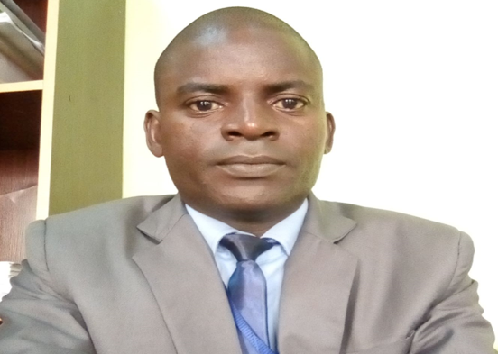

Engr. Dr. Dickson David Olodu is a Nigerian Mechanical Engineer and an academia specializing in Engineering Design and Manufacturing. He hails from Ukwuani Local Government Area of Delta State. He holds a PhD (2017) and M.Eng (2013) in Manufacturing Engineering from the University of Benin, as well as a B.Tech in Electro-Mechanical Engineering (2005) from Nnamdi Azikiwe University, Awka. Currently, Engr. Dr. Dickson David Olodu serves as a Senior Lecturer in the Department of Mechanical Engineering at Benson Idahosa University, where he has been actively involved in teaching and research since 2019. He has held various administrative roles, including Acting Head of Department and Faculty Senate Representative. His research focuses on materials science, composite modeling, design and fabrication, waste to energy and process optimization, with several publications in international and national journals. Engr. Dr. Dickson David Olodu is a registered engineer with Council for the Regulation of Engineers in Nigeria (COREN), registered member international Association of engineers, registered member Society of Petroleum Engineers and a corporate member of the Nigerian Society of Engineers. He has received multiple awards, including the Benson Idahosa University (BIU) Research Productivity Award (2020) and Most Cited Faculty Member in 2022 and 2024 respectively. He is proficient in engineering software and data analysis tools. Engr. Dr. Dickson David Olodu has also participated in various professional training, including a course on *Artificial Intelligence and The Delivery of Quality Higher Education* (2024). He is Married with four children; he continues to contribute significantly to academia and professional engineering practice.